# BUG REPORT

*Newly found Bugs will updated *

## BUG 1

Title: Responsive Log In is needed

Attachment:

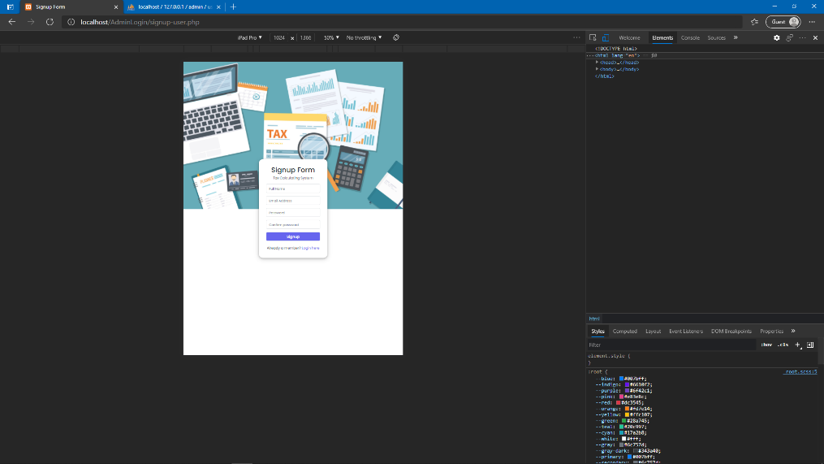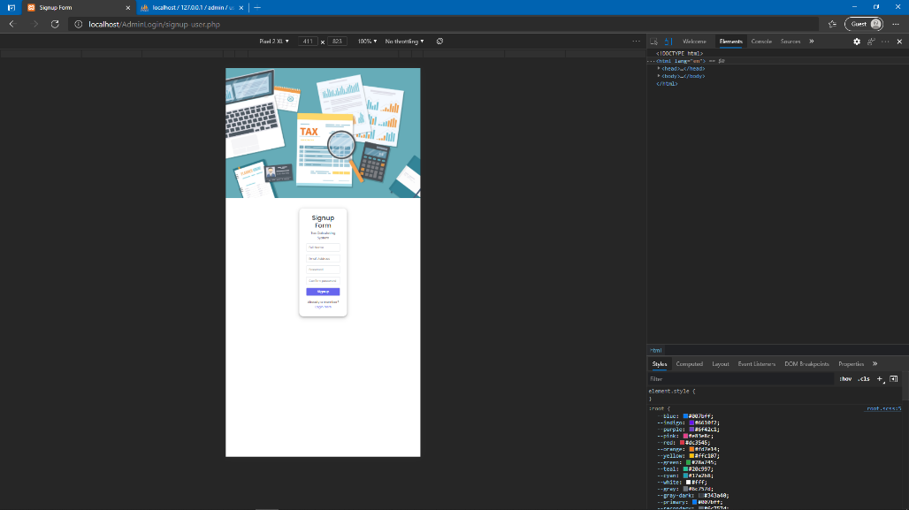

Steps to reproduce:

1. Go to the Admin Log In screen or the forgot password screen
2. Go to inspect
3. Set the responsiveness to one of iPhone
4. Set the responsiveness to one of iPad

Environment: Microsoft Edge Version 90.0.818.56

## BUG 2

Title: Responsive Sign Up is needed

Attachment:

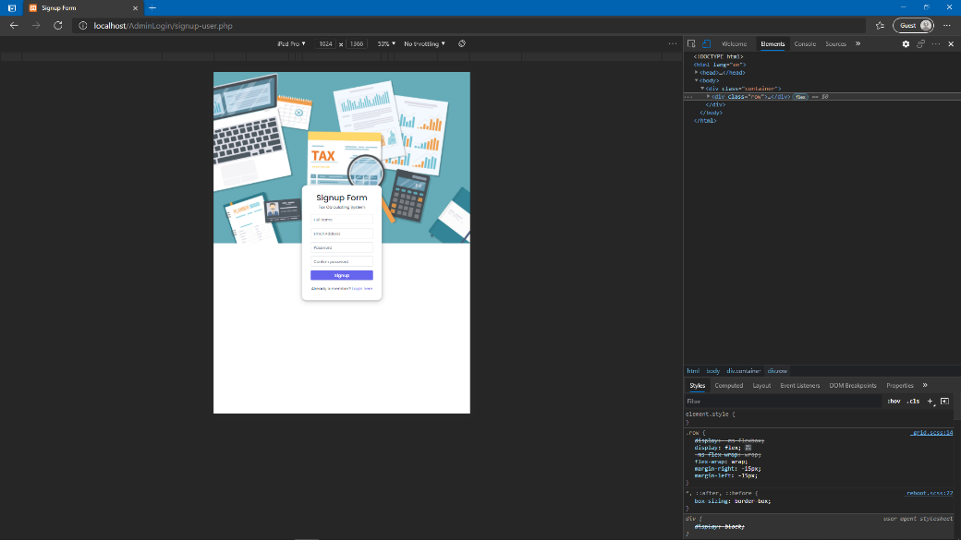

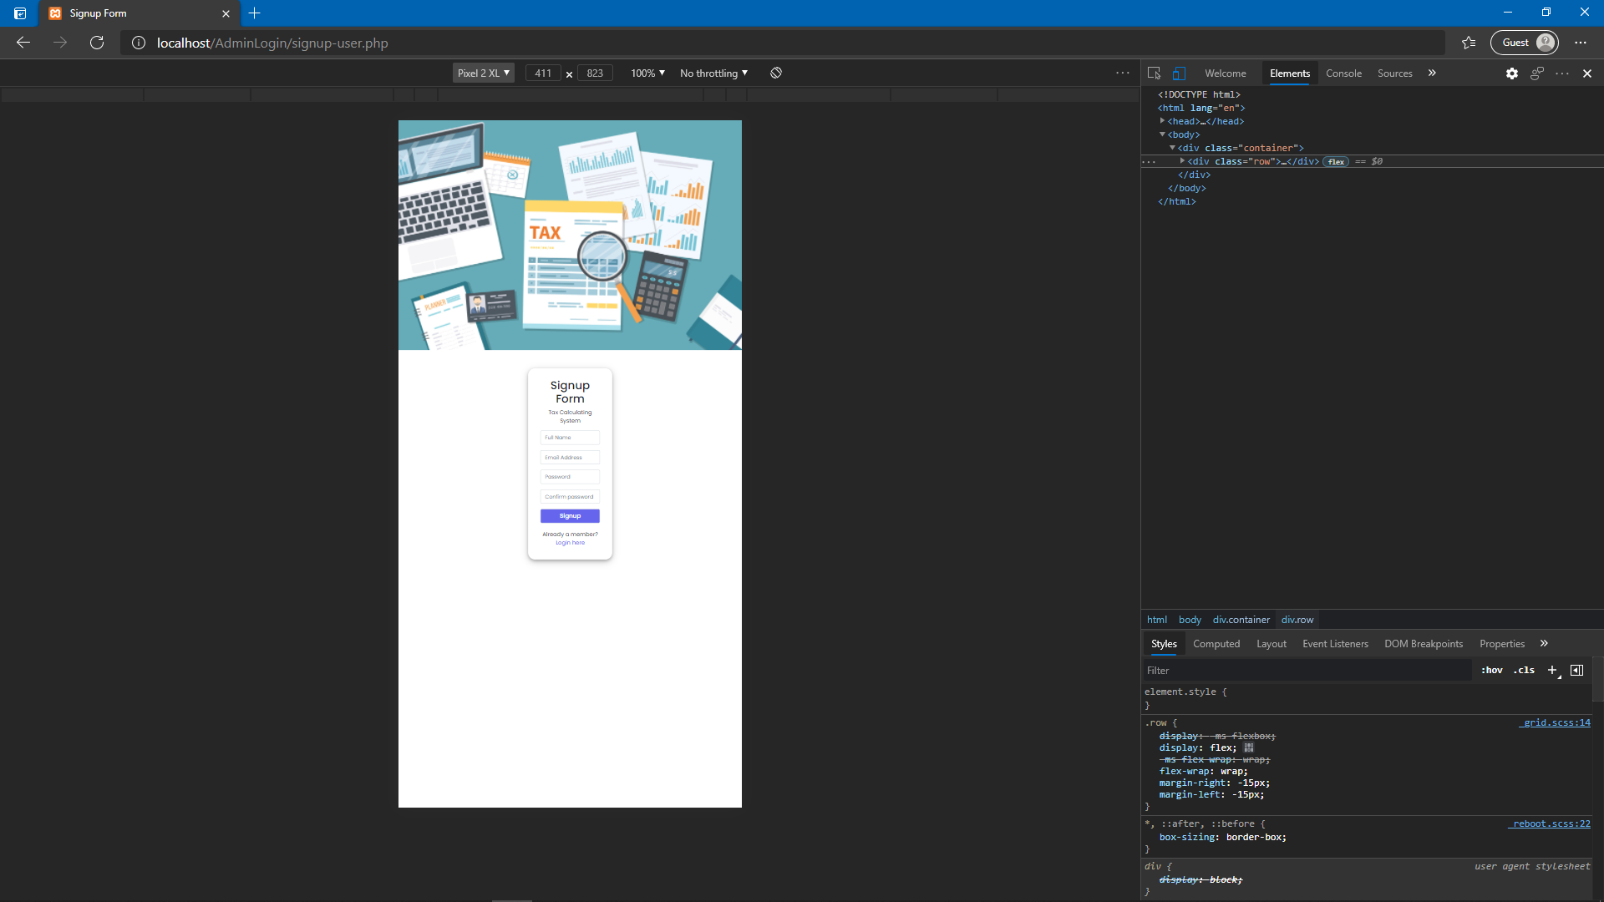

Steps to reproduce:

1. Go to the Admin Log In screen or the forgot password screen
2. Go to inspect
3. Set the responsiveness to one of iPhone
4. Set the responsiveness to one of iPad

Environment: Microsoft Edge Version 90.0.818.56